Program Execution (Screenshots)
Shoot 1: Main menu
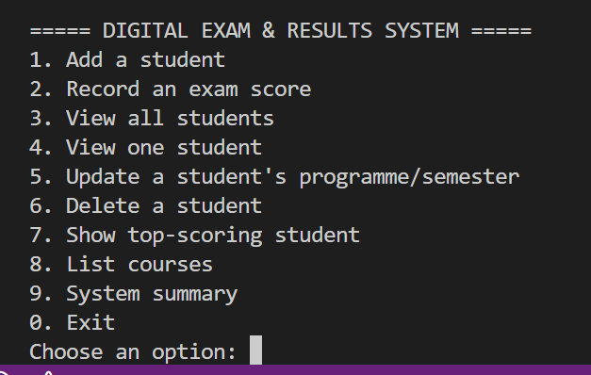

Shoot 2: Viewing all students (option 3)
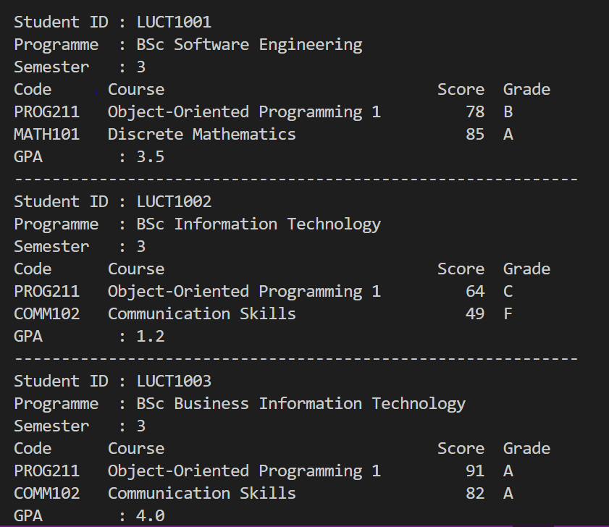

Shoot 3: Recording an exam score (option 2)
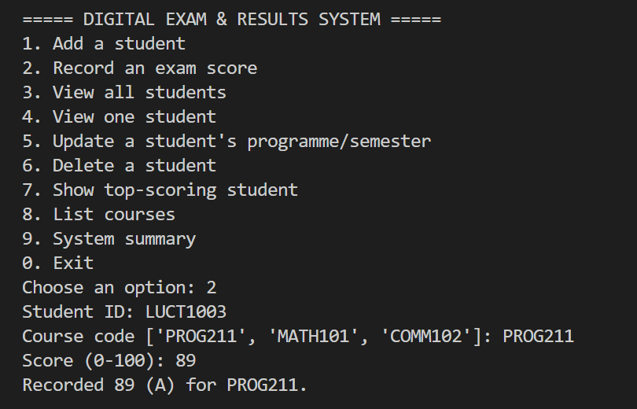
Shoot 4: Invalid score rejected (e.g. 150)
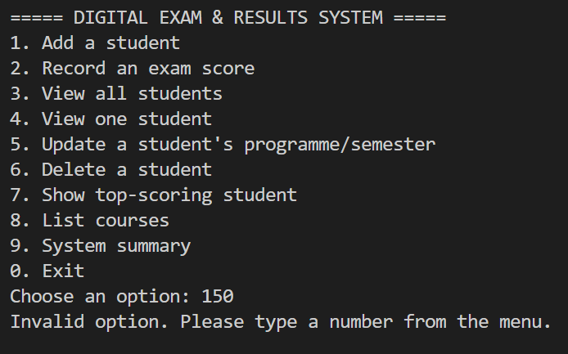

Shoot 5: Top-scoring student before deleting (option 7)
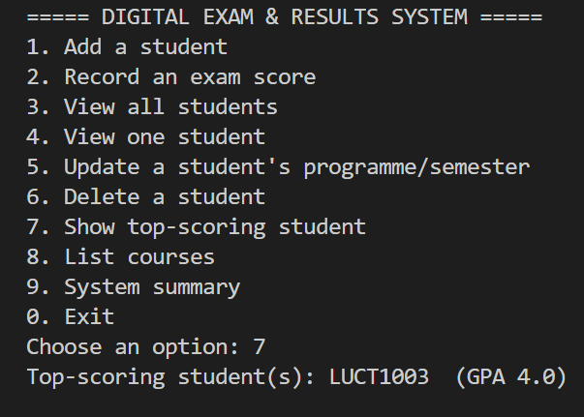
Shoot 6: Deleting a student (option 6)
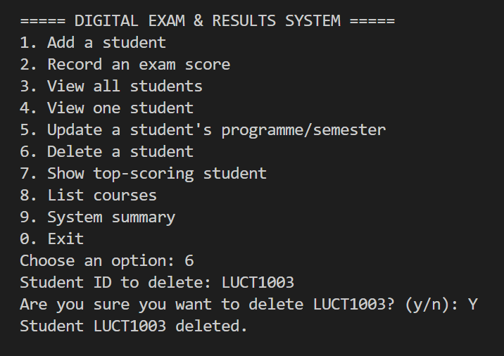

Shoot 7: Top-scoring student after deleting (option 7)
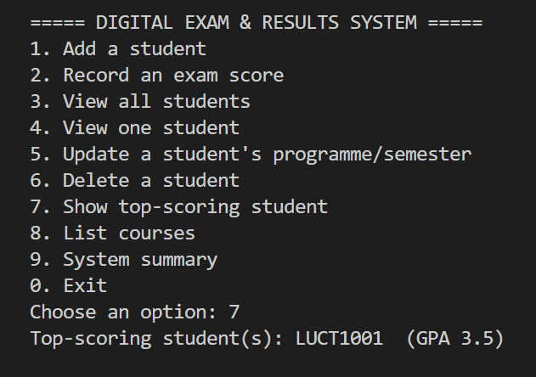
Shoot 8: System summary (option 9)
